Gold Wing Road Riders Association (GWRRA)  The GWRRA motto is  “Friends for Fun Safety and Knowledge”  New Mexico Chapter F meets 1st Saturday of each month  At Golden Corral  Just off I-40 & Coors  Albuquerque, NM 30253  505-831-46071  We eat at 7:30AM and our meeting starts at 8:30AM  For more information the GWRRA, about us, or a map to our meeting location, please take a look at our  web site at www.newmexicochapterf.org or give us a call.  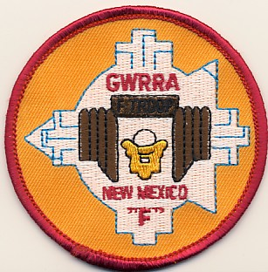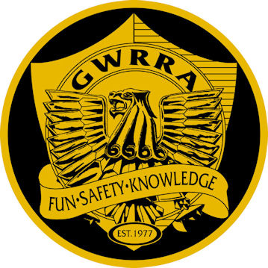 | Gold Wing Road Riders Association (GWRRA)  The GWRRA motto is  “Friends for Fun Safety and Knowledge”  New Mexico Chapter F meets 1st Saturday of each month  At Golden Corral  Just off I-40 & Coors  Albuquerque, NM 30253  505-831-46071  We eat at 7:30AM and our meeting starts at 8:30AM  For more information the GWRRA, about us, or a map to our meeting location, please take a look at our  web site at www.newmexicochapterf.org or give us a call.
Gold Wing Road Riders Association (GWRRA)  The GWRRA motto is  “Friends for Fun Safety and Knowledge”  New Mexico Chapter F meets 1st Saturday of each month  At Golden Corral  Just off I-40 & Coors  Albuquerque, NM 30253  505-831-46071  We eat at 7:30AM and our meeting starts at 8:30AM  For more information the GWRRA, about us, or a map to our meeting location, please take a look at our  web site at www.newmexicochapterf.org or give us a call. | Gold Wing Road Riders Association (GWRRA)  The GWRRA motto is  “Friends for Fun Safety and Knowledge”  New Mexico Chapter F meets 1st Saturday of each month  At Golden Corral  Just off I-40 & Coors  Albuquerque, NM 30253  505-831-46071  We eat at 7:30AM and our meeting starts at 8:30AM  For more information the GWRRA, about us, or a map to our meeting location, please take a look at our  web site at www.newmexicochapterf.org or give us a call.
Gold Wing Road Riders Association (GWRRA)  The GWRRA motto is  “Friends for Fun Safety and Knowledge”  New Mexico Chapter F meets 1st Saturday of each month  At Golden Corral  Just off I-40 & Coors  Albuquerque, NM 30253  505-831-46071  We eat at 7:30AM and our meeting starts at 8:30AM  For more information the GWRRA, about us, or a map to our meeting location, please take a look at our  web site at www.newmexicochapterf.org or give us a call. | Gold Wing Road Riders Association (GWRRA)  The GWRRA motto is  “Friends for Fun Safety and Knowledge”  New Mexico Chapter F meets 1st Saturday of each month  At Golden Corral  Just off I-40 & Coors  Albuquerque, NM 30253  505-831-46071  We eat at 7:30AM and our meeting starts at 8:30AM  For more information the GWRRA, about us, or a map to our meeting location, please take a look at our  web site at www.newmexicochapterf.org or give us a call.
Gold Wing Road Riders Association (GWRRA)  The GWRRA motto is  “Friends for Fun Safety and Knowledge”  New Mexico Chapter F meets 1st Saturday of each month  At Golden Corral  Just off I-40 & Coors  Albuquerque, NM 30253  505-831-46071  We eat at 7:30AM and our meeting starts at 8:30AM  For more information the GWRRA, about us, or a map to our meeting location, please take a look at our  web site at www.newmexicochapterf.org or give us a call. | Gold Wing Road Riders Association (GWRRA)  The GWRRA motto is  “Friends for Fun Safety and Knowledge”  New Mexico Chapter F meets 1st Saturday of each month  At Golden Corral  Just off I-40 & Coors  Albuquerque, NM 30253  505-831-46071  We eat at 7:30AM and our meeting starts at 8:30AM  For more information the GWRRA, about us, or a map to our meeting location, please take a look at our  web site at www.newmexicochapterf.org or give us a call.
Gold Wing Road Riders Association (GWRRA)  The GWRRA motto is  “Friends for Fun Safety and Knowledge”  New Mexico Chapter F meets 1st Saturday of each month  At Golden Corral  Just off I-40 & Coors  Albuquerque, NM 30253  505-831-46071  We eat at 7:30AM and our meeting starts at 8:30AM  For more information the GWRRA, about us, or a map to our meeting location, please take a look at our  web site at www.newmexicochapterf.org or give us a call. | Gold Wing Road Riders Association (GWRRA)  The GWRRA motto is  “Friends for Fun Safety and Knowledge”  New Mexico Chapter F meets 1st Saturday of each month  At Golden Corral  Just off I-40 & Coors  Albuquerque, NM 30253  505-831-46071  We eat at 7:30AM and our meeting starts at 8:30AM  For more information the GWRRA, about us, or a map to our meeting location, please take a look at our  web site at www.newmexicochapterf.org or give us a call.

