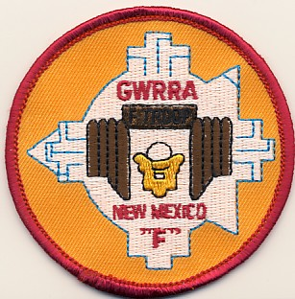  John & Jane Doe  Home 505-123-4567  John’s Cell 505-123-4567  Jane’s Cell 505-123-4567  john.doe@comcast.net  jan.doe@ comcast.net  http://www.your_web_site.com/  Gold Wing Road Riders Association  Albuquerque – Chapter F | John & Jane Doe  Home 505-123-4567  John’s Cell 505-123-4567  Jane’s Cell 505-123-4567  john.doe@comcast.net  jan.doe@ comcast.net  http://www.your_web_site.com/  Gold Wing Road Riders Association  Albuquerque – Chapter F
John & Jane Doe  Home 505-123-4567  John’s Cell 505-123-4567  Jane’s Cell 505-123-4567  john.doe@comcast.net  jan.doe@ comcast.net  http://www.your_web_site.com/  Gold Wing Road Riders Association  Albuquerque – Chapter F | John & Jane Doe  Home 505-123-4567  John’s Cell 505-123-4567  Jane’s Cell 505-123-4567  john.doe@comcast.net  jan.doe@ comcast.net  http://www.your_web_site.com/  Gold Wing Road Riders Association  Albuquerque – Chapter F
John & Jane Doe  Home 505-123-4567  John’s Cell 505-123-4567  Jane’s Cell 505-123-4567  john.doe@comcast.net  jan.doe@ comcast.net  http://www.your_web_site.com/  Gold Wing Road Riders Association  Albuquerque – Chapter F | John & Jane Doe  Home 505-123-4567  John’s Cell 505-123-4567  Jane’s Cell 505-123-4567  john.doe@comcast.net  jan.doe@ comcast.net  http://www.your_web_site.com/  Gold Wing Road Riders Association  Albuquerque – Chapter F
John & Jane Doe  Home 505-123-4567  John’s Cell 505-123-4567  Jane’s Cell 505-123-4567  john.doe@comcast.net  jan.doe@ comcast.net  http://www.your_web_site.com/  Gold Wing Road Riders Association  Albuquerque – Chapter F | John & Jane Doe  Home 505-123-4567  John’s Cell 505-123-4567  Jane’s Cell 505-123-4567  john.doe@comcast.net  jan.doe@ comcast.net  http://www.your_web_site.com/  Gold Wing Road Riders Association  Albuquerque – Chapter F
John & Jane Doe  Home 505-123-4567  John’s Cell 505-123-4567  Jane’s Cell 505-123-4567  john.doe@comcast.net  jan.doe@ comcast.net  http://www.your_web_site.com/  Gold Wing Road Riders Association  Albuquerque – Chapter F | John & Jane Doe  Home 505-123-4567  John’s Cell 505-123-4567  Jane’s Cell 505-123-4567  john.doe@comcast.net  jan.doe@ comcast.net  http://www.your_web_site.com/  Gold Wing Road Riders Association  Albuquerque – Chapter F

